**Designing part:**

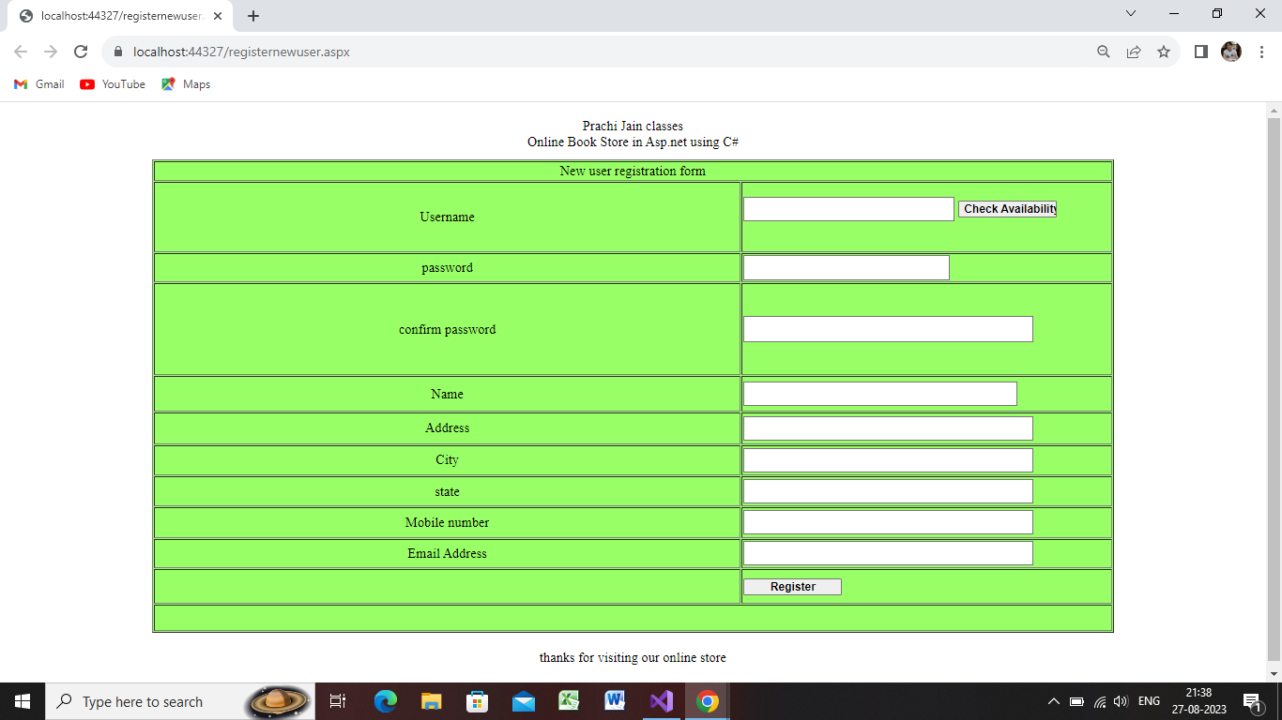

Step 1:open visual studio2019->create new project

Step 2:select ASP.net web application(.net framework)->click on next.

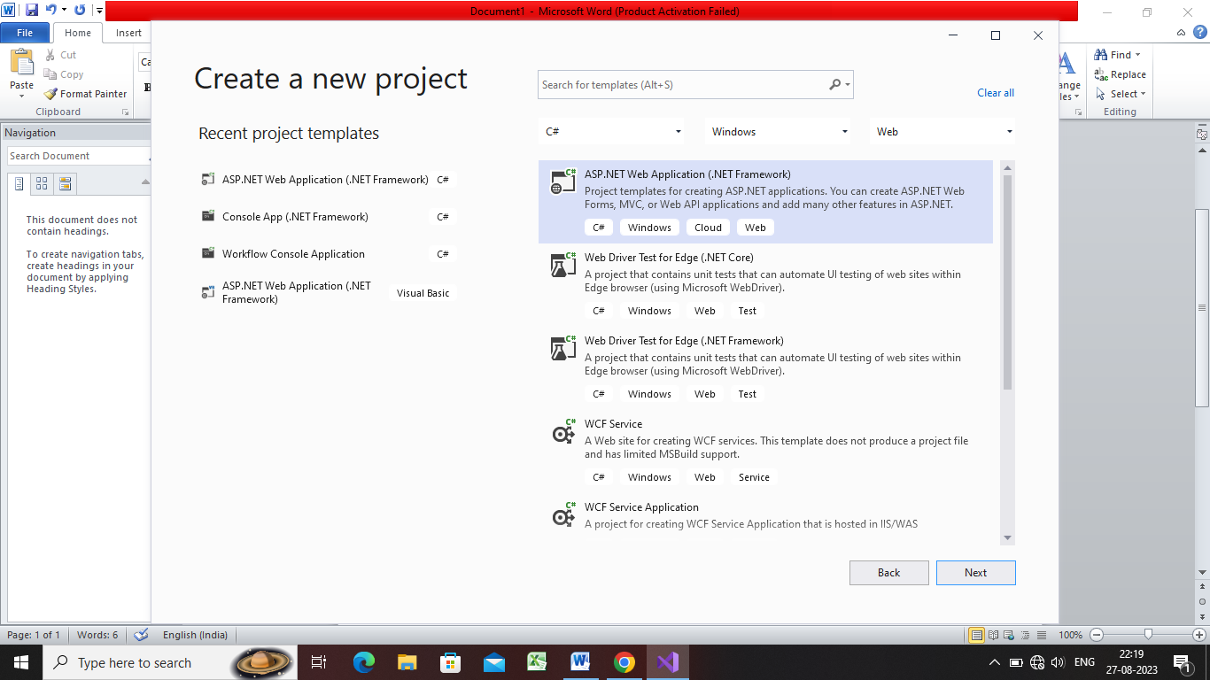

Step 3:give the project name as validation control->create

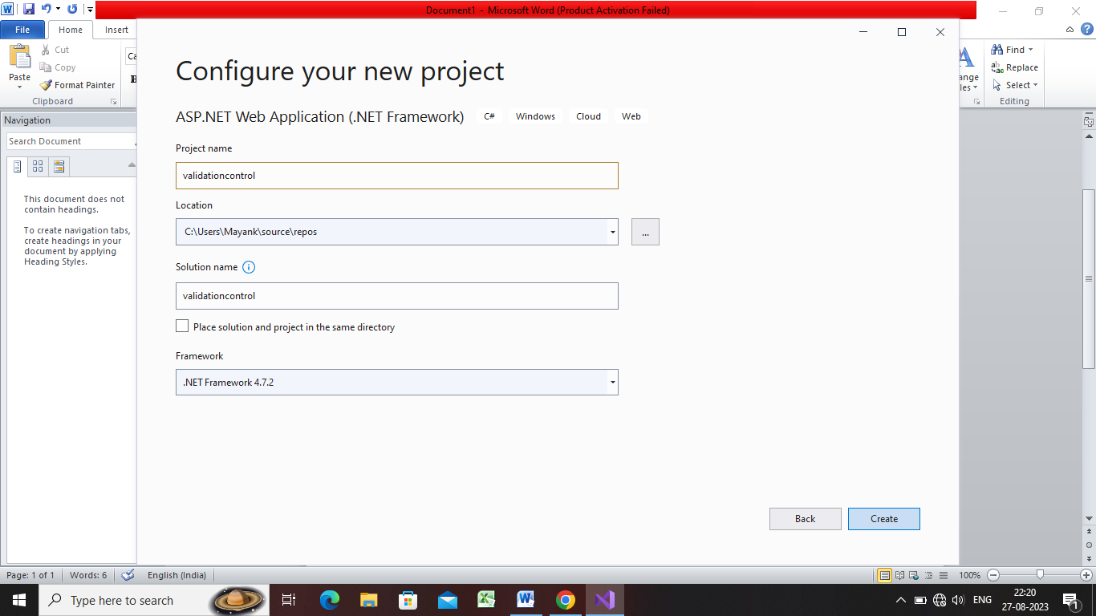

Step 4:select empty project->create

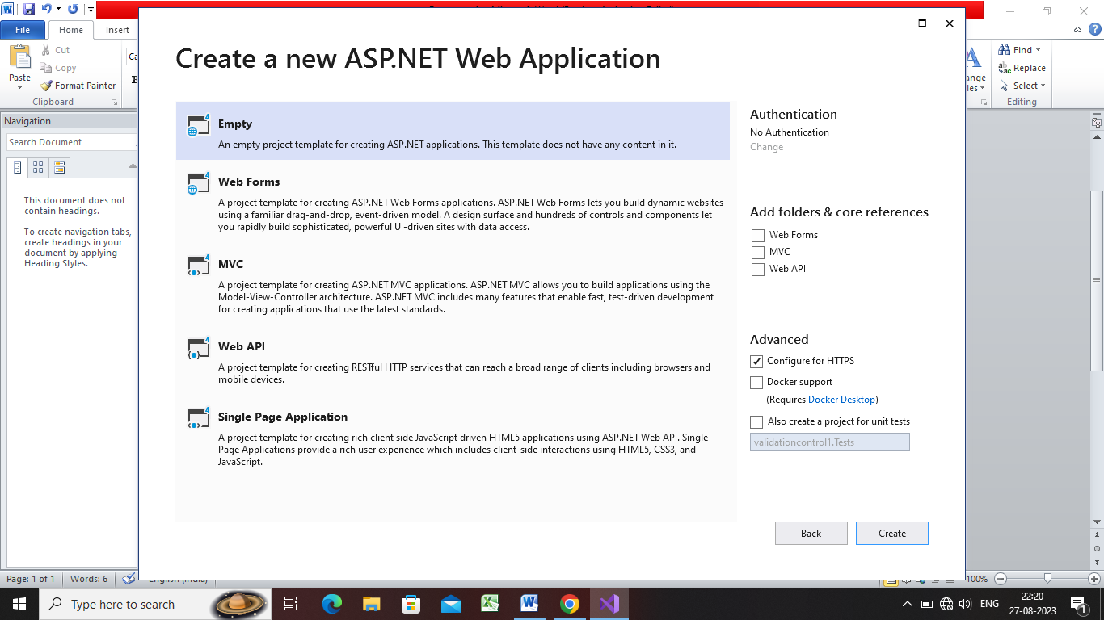

Step 5:now in solution explorer window right click on validation control->add->new item->web form->name:registernewuser->enter

Step5:now registernew user source page show here ,goto design view page

Step 6:click on table->insert table->3 row(header,body,footer)->1coloum

Step 7:insert 12rows and colum 2

And design as per ur choice



Step 8:select table->give it green color->property window->border 1

Step 9:select first row->right click->modify->merge cell

Write new user registration form in first row n align it centre

Step 10:select last row->right click->modify->merge cell

Write thanks for visiting our online store in last row n align it centre

Step 11:design as shown given above

Step 12:put label in username row and add near textbox of username

Step13:add one label at corner of form

Step14: put label in confirm password row and add near textbox of username

Step15:select table and set align centre.

Step16:save everything and run it.

**Validation control part:**

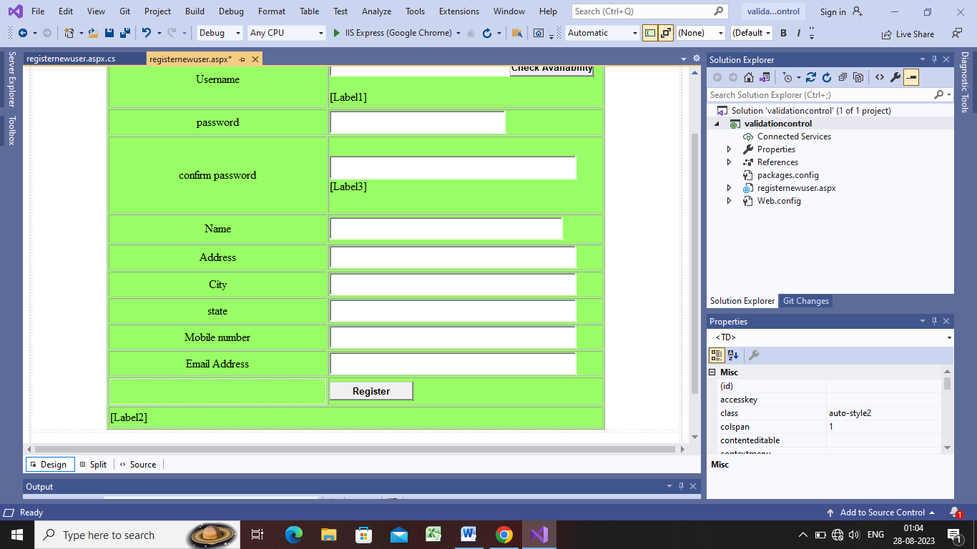

using System;

using System.Collections.Generic;

using System.Linq;

using System.Web;

using System.Web.UI;

using System.Web.UI.WebControls;

namespace validationcontrol

{

public partial class registernewuser : System.Web.UI.Page

{

protected void Page_Load(object sender, EventArgs e)

{

}

protected void Button2_Click(object sender, EventArgs e)

{

if(checkBlankfield())

{

//block1

}

else

{

//block2

if(checkpasswordmatch())

{

Label2.Text = "data properly entered thanks";

}

}

}

bool checkpasswordmatch()

{

if(TextBox2.Text==TextBox3.Text)

{

Label3.Text = "";

//block1

return true;

}

else

{

Label3.Text = "password and confirm password is not match";

Label3.ForeColor = System.Drawing.Color.Red;

//block2

return false;

}

}

bool checkBlankfield()

{

if(TextBox1.Text == "")

{

Label2.Text = "Blank username is not accepted";

Label2.ForeColor = System.Drawing.Color.Red;

return true;

}

if (TextBox2.Text == "")

{

Label2.Text = "Blank password is not accepted";

Label2.ForeColor = System.Drawing.Color.Red;

return true;

}

if (TextBox3.Text == "")

{

Label2.Text = "Blank confirm password is not accepted";

Label2.ForeColor = System.Drawing.Color.Red;

return true;

}

if (TextBox4.Text == "")

{

Label2.Text = "Blank name is not accepted";

Label2.ForeColor = System.Drawing.Color.Red;

return true;

}

if (TextBox5.Text == "")

{

Label2.Text = "Blank address is not accepted";

Label2.ForeColor = System.Drawing.Color.Red;

return true;

}

if (TextBox6.Text == "")

{

Label2.Text = "Blank city is not accepted";

Label2.ForeColor = System.Drawing.Color.Red;

return true;

}

if (TextBox7.Text == "")

{

Label2.Text = "Blank state is not accepted";

Label2.ForeColor = System.Drawing.Color.Red;

return true;

}

if (TextBox8.Text == "")

{

Label2.Text = "Blank mobile number is not accepted";

Label2.ForeColor = System.Drawing.Color.Red;

return true;

}

if (TextBox9.Text == "")

{

Label2.Text = "Blank email address is not accepted";

Label2.ForeColor = System.Drawing.Color.Red;

return true;

}

Label2.Text = "";

return false;

}

}

}